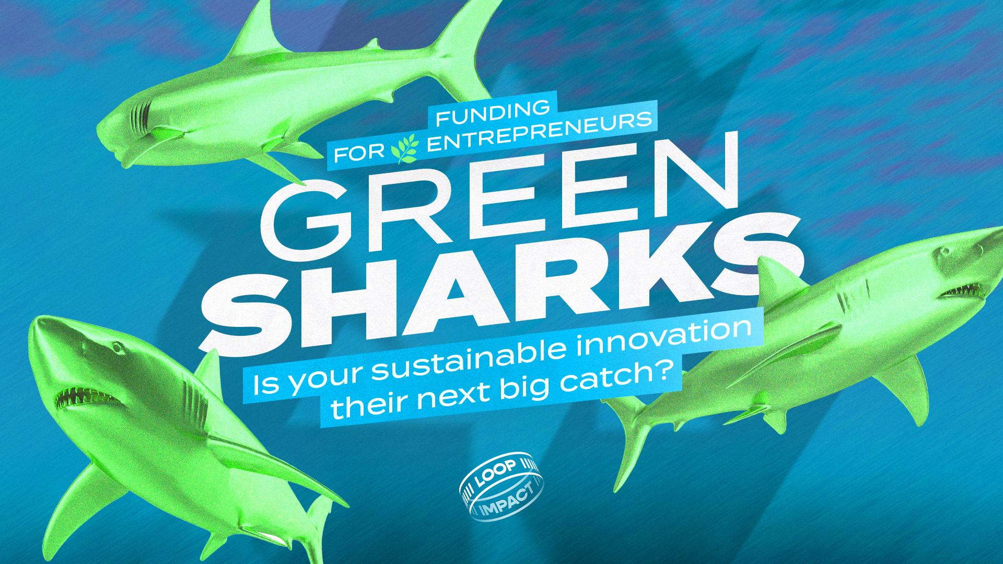

Welcome aboard!

This form will allow you to submit your innovative sustainability project/investment proposal to the green sharks. All organizations with a focus on environmental or social impact that develop a sustainable innovation can submit their project. Depending on their focus and size, projects align with the vision of one or more sharks. More information about the green sharks can be found on the funding page.

The information you provide in this document will of course be treated confidentially and will only be reviewed by the parties involved in the organization of this investment track.

**The deadline for submitting your investment proposal is August 13, 2023 at 23:59.   
Submit by emailing the form to info@loopimpact.eu before the deadline.**

The green sharks will carefully review your application and assess it against the criteria relevant to them.

If you meet the evaluation criteria of one of the sharks and if they take an interest in your project, you will be invited by the organization at the end of the summer for the next round that will start in September. The full procedure with allocation of possible investment from one of the sharks will be completed before the end of 2023.

If you were not withheld for this selection round, you will also be informed and your application will be removed.

General information

**Enter the information in the table below:**

| Company name |  |
| --- | --- |
| VAT number |  |
| Company address |  |
| Company URL |  |
| Number of full-time employees in the company |  |
| First and last name of project submitter |  |
| Function submitter in company |  |
| Phone number submitter |  |
| Submitter's email address |  |

The company

**Indicate one box that applies to your organization:**

| Our organization is a startup in idea phase | ☐ |
| --- | --- |
| Our organization is an operational startup with revenues less than 1000 euros per month | ☐ |
| Our organization is an operational startup with a turnover between 1000 - 7500 euros per month | ☐ |
| Our organization is an operational startup with revenues more than 7500 euros per month | ☐ |
| Our organization is an SME | ☐ |
| Our organization is a large organization | ☐ |

**Indicate all the boxes that apply to your organization (several are possible):**

| Our sustainable innovation focuses on environmental impact | ☐ |
| --- | --- |
| Our sustainable innovation focuses on social impact | ☐ |
| Our sustainable innovation focuses on technological solutions | ☐ |

**Describe your company. Be sure not to use more than 1,5 A4 for this purpose.**  
*Use the following guiding questions:*

* *What does the company do?*
* *How does the company do this?*
* *How does the company generate social and/or environmental impact?*
* *Why does the company do this?*
* *For whom does the company do this?*
* *How large is this target market and how much demand does this target market have for the solution you offer?*
* *What are your medium- and long-term ambitions for this organization? Refer to the social and environmental impact you want to generate.*

*Photos are not counted as text and may be added in this section without regard to the maximum text space capacity for this section.*

***Describe your organization's USP.* Be sure not to use more than 1/2th A4 for this purpose.** *Use the following guiding questions:*

* *Who are your main competitors (with link)?*
* *What do they do?*
* *How does your offering differ from theirs?*

**Describe your organization's business model. Be sure not to use more than 1/2th A4 for this purpose.** *Include the pricing of your products and/or services and refer to the already achieved (financial) results of the organization. Think of x sales in 2022, x gross margin, EBITDA, growth rate, x followers on social media, x online purchases, x reviews above 4 stars,...*

**Describe the shareholder situation below. Please use a maximum of ½ A4 for this purpose.***Use the following guiding questions:*

* *Who are the shareholders?*
* *What % of shares do they each have?*
* *What agreements were made with them that are relevant to this project application?*

The team

**Enter the details of all the organization's founders in the table below:**

| **First name** | **Last name** | **Email** | **Link to LinkedIn profile** |
| --- | --- | --- | --- |
|  |  |  |  |
|  |  |  |  |
|  |  |  |  |

**Enter the details of all the organization's other employees who are significant to this application in the table below:**

| **First name** | **Last name** | **Function** | **Email** | **Link to LinkedIn profile** |
| --- | --- | --- | --- | --- |
|  |  |  |  |  |
|  |  |  |  |  |
|  |  |  |  |  |

**Please describe (the members of) your team in more detail below. Use 1/2 A4 maximum.**  
*Use the following guiding questions:*

* *Who fulfills which role?*
* *Why do you work together so well?*
* *How do you know each other?*
* *How long have you been working together?*

The project application: get them hooked

**Describe your project application. Use 1,5 A4 maximum.**  
*Use the following guiding questions:*

* *What does the project entail?*
* *Why does your organization need funding for this?*
* *How much funding do you need?*
* *What will you use this funding for?*
* *What results do you expect to achieve with this funding?*
* *How will this funding help your organization reach the next level?*
* *What direct and indirect impact will this funding generate ecologically and socially?*
* *Are there any other resources your organization needs to successfully complete this project (specific expertise, experience,...)?*
* *What steps will you take to make good use of this money and the support offered?*
* *What is your action plan/timing?*
* *What will you offer the green sharks in exchange for the requested support (e.g. x % shares, % or fixed amount on sales,...)?*